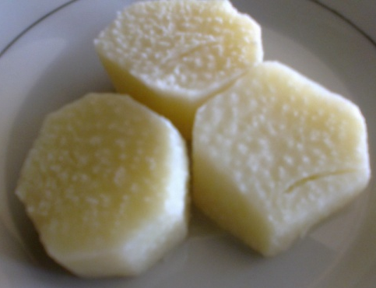
A B

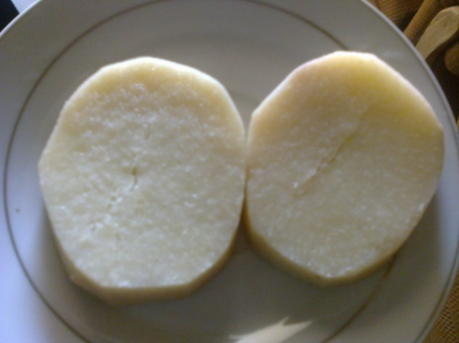
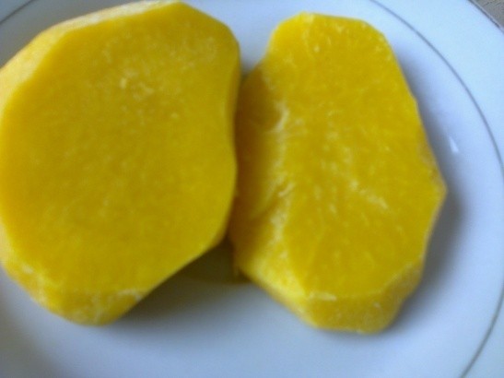
C D

Plate 1: Boiled trifoliate yam
White trifoliate yam - A (9 months) and C (11 months), Yellow trifoliate yam-B (9 months) and D-(11months)

