  - Table 1: Mortality of banana pseudostem weevilto different concentrations of Menma.
Con. (ppm) | Mortality of O. longicollis  ( HAT)
 | 0.5 | 1 | 2 | 4 | 6 | 8 | 10 | 12 | 14 | 16 | 18
4 | 0 | 0 | 0 | 0 | 0 | 0 | 0.3±0.57 ^{d} | 0.3±0.57 ^{d} | 1.3±0.57 ^{c} | 2.6±0.57 ^{b} | 5±0 ª
8 | 0 | 0 | 0 | 0 | 1±1 ^{b} | 1.6±0.57 ^{b} | 4.3±0.57 ª | 5±0 ª | 5±0 ª | 5±0 ª | 5±0 ª
10 | 0 | 0.3±0.57 ^{d} | 0.3±0.57^{d} | 1.3±0.57 ^{c} | 3.6±1.15 ^{b} | 5±0 ª | 5±0 ª | 5±0 ª | 5±0 ª | 5±0 ª | 5±0 ª
20 | 2.3±0.57 ^{c} | 4±0.57^{b} | 5±0 ª | 5±0 ª | 5±0 ª | 5±0 ª | 5±0 ª | 5±0 ª | 5±0 ª | 5±0 ª | 5±0ª

Mean ± SD. Rep. 3; n= 5
Letters of the same in the same column are statistically non-significant.

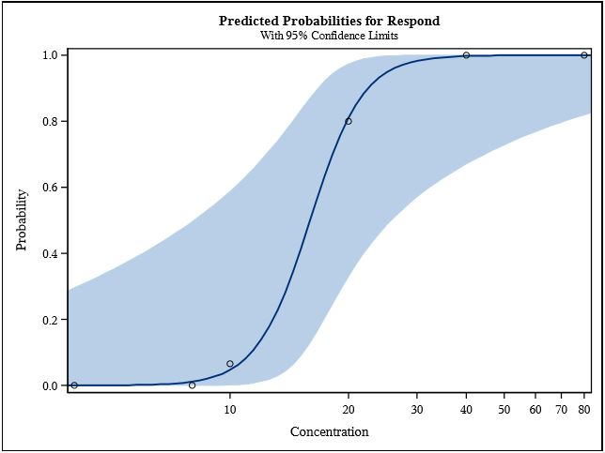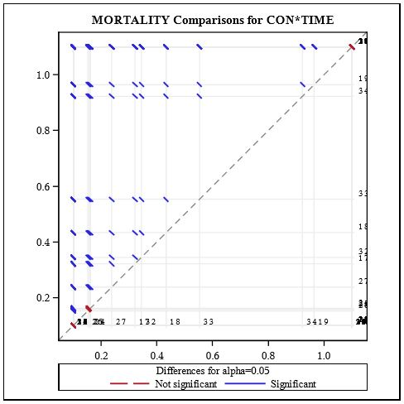
  - Fig, 1a: Mortality curve of O. longicollis to varying concentration of Menma with 95% confidence limits

  - Fig, 1b; Significance sketch with 95% confidence limit to mortality of O. longicollis (in LS Means) for varying concentration of Menma with time

  - Fig, 2; Scatter plot of LC₅₀ values of O. longicollis for all different time periods observed

  - Table, 2: Mortality of banana pseudostem weevil for different doses to Menma.
- Dose (ml) |  | - Mortality of O. longicollis at different  - HAT
 |  | - 0.5 | - 1 |  | - 2 | - 4 |  | - 6 | - 8 |  | - 10 | - 12 |  | - 14
- 2 |  | - 0 | - 0 |  | - 0 | - 0 |  | - 0.3±0.57e | - 1.6±0.57^{d} |  | - 2.6±0.57^{c} | - 3.6±0.57^{b} |  | - 5±0 ª
- 3 |  | - 0 | - 0 |  | - 0 | - 0.3±0.57e |  | - 1.3±0.57^{d} | - 2.6±0.57^{c} |  | - 4.3±0.57^{b} | - 5±0ª |  | - 5±0 ª
- 4 |  | - 0 | - 0.3±0.57e |  | - 2.3±0.57^{d} | - 2.6±0.57^{c} |  | - 4.6±0.57^{b} | - 5±0 ª |  | - 5±0 ª | - 5±0ª |  | - 5±0 ª
- 5 |  | - 0 | - 2.6±0.57^{c} |  | - 4.3±0.57^{b} | - 5±0 ª |  | - 5±0 ª | - 5±0 ª |  | - 5±0 ª | - 5±0 ª |  | - 5±0 ª
- 6 |  | - 2.6±0.57^{d} | - 3±0.57^{c} |  | - 4.3±0.57^{b} | - 5±0 ª |  | - 5±0 ª | - 5±0 ª |  | - 5±0 ª | - 5±0 ª |  | - 5±0 ª
Mean ± SD. Rep. 3; n= 5
Letters of the same in the same column are statistically non-significant.

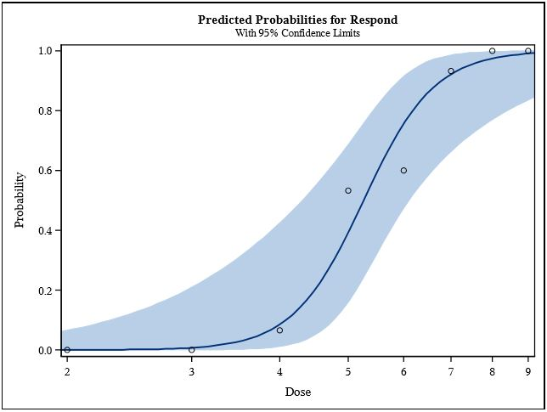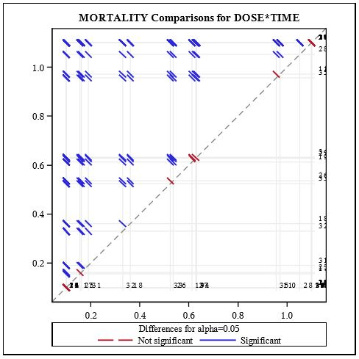
  - Fig, 3b; Significance sketch with 95% confidence limit to mortality of O. longicollis (in LS Means) for varying dose and time with Menma.

  - Fig, 3a: Mortality curve to O. longicollis over varying dose of Menma with 95% confidence limits

  - Fig, 4; Scatter plot indicating the LD₅₀ values of O. longicollis for all the respective time periods observed in the study

  - Table, 3: Mortality of banana pseudostem weevil at different exposure periods to Menma.
Exposure (h) | Mortality of O. longicollis at different  HAT
 | 0.5 |  |  | 1 | 2 |  | 5 | 8 | 10 |  | 12 | 24 |  | 48
6 | 0 |  |  | 0.3±0.57^{g} | 0.3±0.57^{g} |  | 1.6±0.57^{f} | 2.3±0.57e | 2.6±0.57e |  | 4±0^{c} | 4.6±0.57^{b} |  | 5±0ª
8 | 0 |  |  | 0.6±0.57^{g} | 1.3±0.57^{f} |  | 2±0.57e | 2.6±0.57^{d} | 3±0.57^{c} |  | 4.3±0.57^{b} | 5±0ª |  | 5±0ª
10 | 0 |  |  | 0.3±0.57^{f} | 1.6±0.57e |  | 2.3±0.57^{d} | 3±0.57^{c} | 3.3±0.57^{b} |  | 5±0ª | 5±0ª |  | 5±0ª
12 | 0.3±0.57^{g} |  |  | 1±0^{f} | 2.3±0.57e |  | 2.6±0.57^{d} | 3.3±0.57^{c} | 3.6±0.57^{b} |  | 5±0ª | 5±0ª |  | 5±0ª
14 | 0.6±0.57^{f} |  |  | 2±0.57e | 3±0.57^{d} |  | 3.6±0.57^{c} | 4.3±0.57^{b} | 5±0ª |  | 5±0ª | 5±0ª |  | 5±0ª

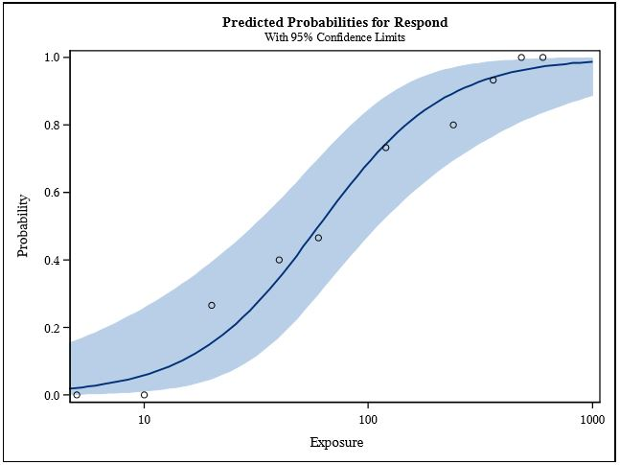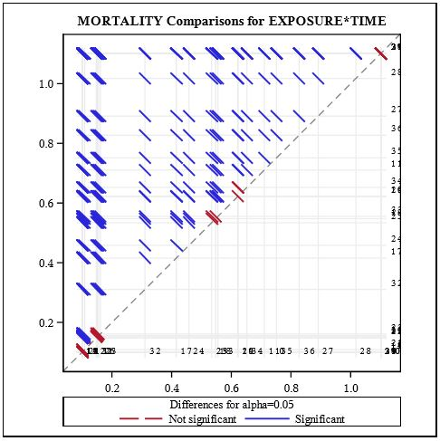
  - Fig, 5b; Two-way ANOVA significance sketch with 95% confidence limit to mortality of O. longicollis (in LS Means) for varying exposure period and time of Menma

  - Fig, 5a: Mortality curve of O. longicollis to varying exposure period to Menma with 95% confidence limits

  - Fig, 6; Scatter plot indicating the KDT₅₀ values of O. longicollis for all the respective time periods observed in the study

